November 24, 2025

STAHL CraneSystems GmbH

Daimlerstraße 6

74653 Künzelsau

STAHL CraneSystems is expanding its wire rope hoist range with the SXD series featuring pole-changeable three-phase motors

Compact and sturdy SXD wire rope hoists with pole changeover for two-stage movement of heavy loads in main and fine hoists

Künzelsau, October 23rd, 2025 – STAHL CraneSystems, a Columbus McKinnon Corporation (CMCO) company and specialist in hoists and crane components, is launching the new SXD series, a compact range of wire rope hoists with 2-speed control for lifting capacities up to 10,000 kg and lifting heights up to 12 m. The pole-changeable SXD (Dual Speed) wire rope hoist is the systematic further development of the SH wire rope hoist and is characterised by its simple and proven technology.

Compact wire rope hoist series with high performance and long service life

Single-girder bridge cranes with compact SXD wire rope hoists move parts and components weighing up to 10 tonnes, even in small production halls and confined storage areas, with hoisting speeds of up to 6 m/min in the main hoist (60 Hz). You can conveniently operate the SXD using a wired STH control pendant or Magnetek push-button radio controls.

The standard condition monitoring function plus the reduced mechanical load thanks to a suppression function in so-called jog mode ensure long-lasting, safe and reliable control of the hoist. The components are protected and wear is reduced considerably. The low-maintenance components of the modular SXD wire rope hoist are carefully coordinated and guarantee high performance and a long service life.

Easy to use and safe in every respect

The wire rope hoist has a low self-weight and is reliable and virtually maintenance-free thanks to a gear with lifetime lubrication. The hoist weighs only around 540 kg with a lifting capacity of 10,000 kg, subject to the selected configuration, making it one of the lightest in its performance class worldwide. Its optimised, streamlined frame design makes installation and commissioning much easier. No specialist knowledge is required, as the training required is minimal. The optimised through-drive shaft with adjustable flange area makes on-site adjustment easier.

The SXD wire rope hoist boasts a range of safety features that reduce wear and tear and increase versatility. These include optimised rope guides with integrated finger protection on the bottom hook block's return sheave and a low-maintenance brake that operates with minimal wear thanks to motor management and doesn't need readjusting. Its permanent electronic load monitoring prevents load peaks when lifting heavy weights. A safe shutdown is triggered immediately in the event of an overload.

SXD and SXF – each powerful in its own way

A continuously adjusting safety brake system and the Multicontroller SMC4 provide additional safety for the SXF frequency-controlled wire rope hoist. This permanently monitors important technical operational data and automatically determines, among other things, the resulting load collective. Communication is carried out over a serial Modbus interface. The IMPULSE·G+ Mini frequency converters ensure that safe operating limits are maintained. The fully integrated brake system in the frequency converter facilitates smooth, quiet operation.

Hoists available in CraneKit

Both the SXD with pole changing as well as the frequency-controlled SXF are available as individual wire rope hoists or as part of CraneKits from STAHL CraneSystems for the installation of overhead and bridge cranes. This is particularly appealing to crane manufacturers and system builders who are on the lookout for simple, safe, and dependable solutions. The plug-and-play principle means that the electrical components can be installed quickly and easily.

Further information

on the SXD and SXF wire rope hoist series is available here:

https://www.cmco.com/de-de/systemloesungen/hebetechnik/seilzug-sxd-sxf/

About Columbus McKinnon

The Columbus McKinnon Corporation (CMCO) boasts a history spanning more than 150 years. The company is a global leader in lifting and intelligent movement control technology. Three business platforms are united under one roof: Lifting Solutions (hoists, crane systems and lifting accessories), Linear Motion Solutions (lifting columns, lifting systems and winches) as well as Conveyance Solutions (conveyor systems and conveyor belts). CMCO is a global organisation headquartered in Buffalo, New York. Its global presence covers offices and production facilities in North America, Latin America, Europe, Africa and Asia. CMCO products are used in over 50 countries. 3,000 employees around the world generate sales of over US$1 billion (2024). The innovative product portfolio featuring high-quality brands such as STAHL CraneSystems, Yale, Pfaff-silberblau, Dorner and montratec responds to customer needs by increasing safety in companies and promoting their growth and efficiency. www.cmco.com

About STAHL CraneSystems

The STAHL CraneSystems brand is synonymous with reliable and safe hoists and crane components as well as methodical engineering solutions. The products are used in standard, special and explosion-proof bridge cranes or lifting systems in industries including automotive, oil and gas, power plant construction, chemical industry, transport and logistics, steel and concrete industry, mechanical and plant engineering, aerospace industry, as well as in the pharmaceutical and food industries. www.cmco.com/de/stahlcranes

Company contact:

STAHL CraneSystems GmbH | Daimlerstr. 6 | 74653 Künzelsau

Heike Metzger, Tel.: +49 7940 128-2388

E-Mail: heike.metzger@stahlcranes.com

Images and captions:

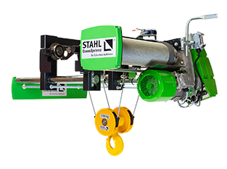
Image 1. STAHL CraneSystems is expanding its wire rope hoist range with the SXD series featuring pole switching for two-stage movement of loads in main and fine hoist modes.

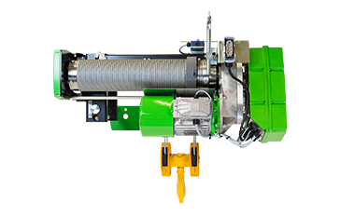
Image 2. The compact SXD wire rope hoists provide an efficient and reliable lifting solution for horizontal and vertical load transport in a wide variety of industrial applications.

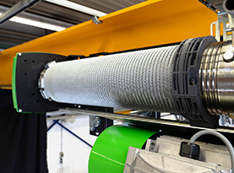
Image 3. The improved rope guide protects the rope, prevents it from being overwound, reduces maintenance requirements thanks to simple installation, as well as ensuring reliability and safety.

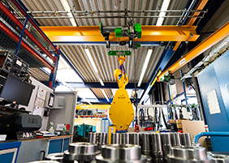
Image 4. Single girder bridge cranes from the CraneKit by STAHL CraneSystems with the new SXD and SXF wire rope hoist series facilitate the efficient transport of components.

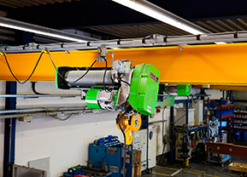
Image 5. The SXD wire rope hoist in a typical industrial application environment.

