6 May 2026

Columbus McKinnon
c/o STAHL CraneSystems GmbH

Daimlerstraße 6

74653 Künzelsau, Germany

Crane system refurbishment for more efficient repair of steel bridges

By refurbishing its crane systems, the DB Bahnbau Group’s bridge workshop is investing
in optimised heavy-duty assembly

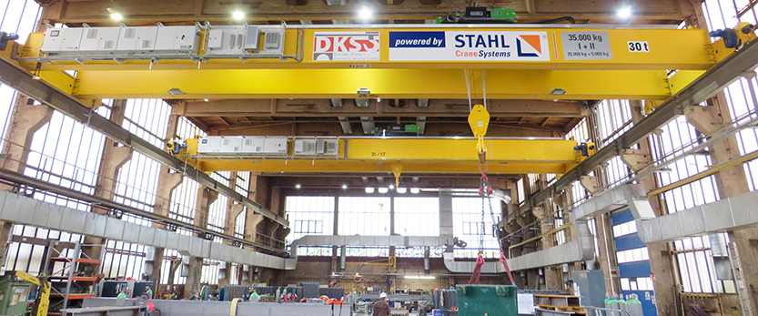

At the DB Bahnbau Group’s bridge workshop in Dresden – a subsidiary of Deutsche Bahn (DB) – the cranes have been replaced after five years. Due to declining availability of the crane systems, action was needed to ensure long-term operational reliability. The contract to overhaul the systems was awarded to Dresden Krane + Industrie Service (DKS). The company has been working with DB since 2023 and carries out all inspections and repairs there. The control system was designed and the new tandem crane system commissioned by STAHL CraneSystems in October 2025.

Deutsche Bahn relies on high-performance technology to modernise its infrastructure. New crane systems were therefore installed at the Dresden bridge workshop to improve the availability and efficiency of operations. Around 100 employees at the company are responsible for the repair and construction of railway bridges on a site comprising four halls. The range of services includes the manufacture of steel superstructures and temporary bridges, involving welding and anti-corrosion work. In 2025, the company modernised its crane system to improve the conditions for cost-effective repair operations.

Concentrated expertise in the bridge workshop for almost 100 years

The bridge workshop is certified under DBS 918005 for welding, steel construction and corrosion protection. This standard sets out the technical specifications for the construction of steel structures in railway bridge building and other civil engineering works where railway loads are involved. The facility, which has been part of the DB Bahnbau Group since 2010, is located in Dresden’s Neustadt district and will celebrate its 100th anniversary in 2027. The experience and expertise concentrated there is correspondingly vast. The experts are proficient in every stage of bridge construction and modernisation – from planning and fabrication through to assembly and repair.

Numerous projects have already been successfully completed. One of these was the Becker Bridge, also known as the Chemnitz Viaduct. It is regarded as one of the most beautiful steel structures in Germany. Built in 1901, this iron structure spans the River Chemnitz and is used by trains on the Dresden–Werdau line. From early 2022 to late 2024, the bridge workshop of the DB Bahnbau Group and heritage authorities worked together to restore the 275-metre-long, listed structure, adapting it to meet today’s rail transport requirements. All welding work and anti-corrosion measures for the modernisation took place in the bridge workshop.

Hundreds of steel bridges need refurbishment

There are around 30,000 railway viaducts in Germany, 8,500 of which are steel structures. Some of these have already been refurbished at the Dresden Bridge Workshop, whilst many bridges are still awaiting refurbishment. The Bridge Workshop believes it is economically viable to replace the bracing or bearings on these bridges and renew the corrosion protection. However, there is a challenge: the steel components of the bridges are usually large and heavy. A reliable crane system is therefore essential for this repair work.

Although the old crane system is still relatively new, it was already showing the first signs of wear and tear due to intensive use and the heavy loads in the welding hall. In particular, the availability of the existing hoists, their use in tandem operation and the reliability of the existing radio controls were showing increasing deterioration. By early 2024, the risk of reduced operational reliability had become so acute that a comprehensive refurbishment was required. Consequently, the DB Bahnbau Group commissioned DKS Kranservice in Pirna to plan the refurbishment of the crane system in the so-called large welding hall.

Crane refurbishment including completely overhauled control technology

The crane service company DKS has been working on behalf of DB since 2023, carrying out inspections and repairs on crane systems. As a reliable partner for the maintenance and optimisation of crane and lifting technology, DKS covers the full spectrum of services, from repairs and maintenance through to automation, safety retrofitting and periodic inspections. In November 2024, the project in Dresden finally got underway, implemented using crane components from STAHL CraneSystems.

The DKS supply included, amongst other things, two double-rail trolleys, each with an ASF7063 wire rope hoist for loads up to 35 t and an SHF4012 auxiliary hoist for loads up to 5 t. In addition, the package included the SMC22 multicontroller, an HBC master-slave radio system and a fully integrated, programmable logic controller (PLC) for lifting, trolley and crane travel, all housed within the control cabinet. Technical implementation began in August 2025. DKS dismantled the existing crane components and installed new hoists, control boxes and the electrical systems. The conversion took place whilst operations continued; STAHL CraneSystems was responsible for the final commissioning of the tandem crane system.

Modular construction processes in the welding hall

In principle, steel structures allow for a modular construction process. Steel bridges consist of defined individual components, such as arch and girder segments. These are supplemented by other elements, including piers, plate girders, substructures and superstructures, as well as the deck. The individual components of the bridge offer opportunities for prefabrication and for adapting existing bridge structures. Furthermore, the individual segments can be easily replaced or maintained and repaired separately.

Machining operations, such as cutting, drilling or milling of components, take place in the bridge workshop in Hall 1. In Hall 2, known as the welding hall, the prepared steel components – including large and heavy T-beams with a height of 1.30 m – are assembled. Two new master-slave tandem crane systems are now in operation in this hall. The span is 22 m, the lifting height 10 m. The new ASF7063 main hoist can handle loads of up to 35 t at adjustable lifting speeds ranging from 0.08 m/min to a fast 4.20 m/min. In addition, there is the SHF4012 auxiliary hoist for assisting lifting tasks, which moves loads of up to 5 t at speeds of up to 8 m/min.

Power is supplied to the hoist via an energy chain, which is designed for a span of 22 m and is mounted in a guide channel on the upper flange of the bridge girder. This has the advantage that, in addition to the power supply, data cables for the sensors and communication (Profinet and Profisafe) can be carried along with the hoist in a protected and organised manner. At the same time, the system operates reliably because there are no sliding contacts that could wear out or cause problems in adverse environmental conditions. In this heavily used system, the energy chain ensures reliability, safety and stable data transmission.

Distance-controlled tandem operation with electronic load summation

The double-rail top-girder crane moves the heavy steel bridge sections reliably and quickly at speeds of up to 25 m/min to ensure efficient operation. In tandem operation, the two cranes take predefined maximum loads into account. The corresponding communication system between the two cranes has been implemented wirelessly.

The programmable logic controller monitors all the operating conditions of the two cranes. When operating within the trolley travel range (less than 4 metres), the total load must not exceed 30 tonnes. Furthermore, for structural reasons, the two cranes must be positioned 11 metres apart when operating at full load, so as not to exceed the load capacity of the foundations. At low load capacities, they can operate closer together. Accordingly, the control system was designed to meet Performance Level d. Furthermore, the customer expressly requested that maintenance work be supported via the touch panel.

The crane, whose drives are equipped with frequency converters, is controlled by a central crane control system on the crane bridge. This comprises the programmable logic controller and the SMC22 multi-controller. The latter continuously monitors important technical operating data in real time and, among other things, automatically determines the resulting load collective. The operating data can be programmed and read out using a laptop in various file formats.

With its automatic load control (ALC+), the multi-controller prevents load peaks when lifting heavy weights. The built-in programmable logic controller handles the electronic load summation and enables the simultaneous lifting of loads from the main hoist and auxiliary hoist without exceeding the maximum lifting capacity of 35 tonnes. In the event of an overload, a safe shutdown occurs immediately. Continuous load monitoring is carried out in accordance with Performance Level PL d, Category 2, as per EN 13849-1. This ensures the demonstrably safe operation of the tandem crane system when transporting steel components in the welding hall.

Control crane movement in master-slave mode via radio

The operator uses a master-slave radio system from HBC-radiomatic in Crailsheim – a manufacturer of industrial radio remote controls for cranes, construction machinery and specialised equipment – to operate the cranes. This radio control system, known as ‘technos’, involves a main transmitter (master) working in conjunction with additional transmitters (slaves).

The secondary control units (slaves) enable safe and flexible control by additional personnel. If, for example, precise assembly of the steel components is required in the hall, a technician takes control of the slave directly on site. Control is then switched back to the main control unit (master). This supports an efficient manufacturing process in Hall 2.

After joining, the cranes help transport the welded steel components to Hall 3. This is where the preservation process takes place, as the bridges are designed to last for many years and be as maintenance-free as possible. For this reason, the components are blast-cleaned with steel grit in Hall 3. This removes scale and creates a defined surface roughness for a durable paint finish. After the so-called preservation process involving painting, the steel components are ready for assembly and can be transported to the construction site together with the assembly components stored in Hall 4, where staff from the bridge workshop take care of the assembly and final inspection.

Conclusion

In the welding hall of the DB Bahnbau Group’s bridge workshop, crane systems must not only be designed for heavy loads and harsh environments, but also offer high availability. STAHL CraneSystems has various solutions in its product portfolio for its partner company DKS Kranservice that are designed for harsh operating conditions, including control technology and the relevant expertise in drawing up circuit diagrams. The refurbished tandem crane system at the DB workshops in Dresden demonstrates that such conversion projects can be planned within a year and integrated into ongoing production operations within a few weeks.

About the DB Bahnbau Group

DB Bahnbau Gruppe GmbH is a wholly-owned subsidiary of Deutsche Bahn AG and is one of the leading providers of construction, maintenance and modernisation services for railway infrastructure in Germany. With over 4,000 employees and around 700 maintenance vehicles, the company provides planning, construction and maintenance services for infrastructure facilities, particularly railway infrastructure and rail transport services. For almost 100 years, the Dresden Bridge Workshop has been producing products of the highest quality, driven by passion and tradition. The portfolio ranges from the restoration of listed components to the development of the longest temporary bridge. The DB Bahnbau Group is a leading player in railway bridge construction. With almost a century of experience and innovations for the next century.

About Columbus McKinnon

The Columbus McKinnon Corporation (CMCO) boasts a history spanning more than 150 years. The company is a global leader in lifting and intelligent movement control technology. Three business platforms are united under one roof: Lifting Solutions (hoists, crane systems and lifting accessories), Linear Motion Solutions (lifting columns, lifting systems and winches) as well as Conveyance Solutions (conveyor systems and conveyor belts). CMCO is a global organisation headquartered in Buffalo, New York. Its global presence covers offices and production facilities in North America, Latin America, Europe, Africa and Asia. CMCO products are used in over 50 countries. 3,000 employees around the world generate sales of over US$1 billion (2024). The innovative product portfolio featuring high-quality brands such as STAHL CraneSystems, Yale, Pfaff-silberblau, Dorner and montratec responds to customer needs by increasing safety in companies and promoting their growth and efficiency. www.cmco.com

About STAHL CraneSystems

The STAHL CraneSystems brand is synonymous with reliable and safe hoists and crane components as well as methodical engineering solutions. The products are used in standard, special and explosion-proof bridge cranes or lifting systems in industries including automotive, oil and gas, power plant construction, chemical industry, transport and logistics, steel and concrete industry, mechanical and plant engineering, aerospace industry, as well as in the pharmaceutical and food industries. www.cmco.com/en/stahlcranes

Author: Heike Metzger, Senior Specialist, Sales Enablement, STAHL CraneSystems GmbH, Künzelsau

Company contact:

Heike Metzger, Tel.: +49 7940 128-2388

E-Mail: heike.metzger@stahlcranes.com

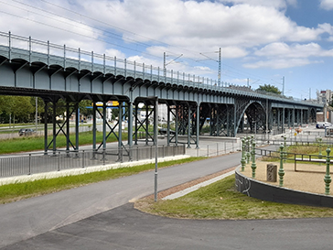
Images and captions

Image 1 Chemnitz steel viaduct
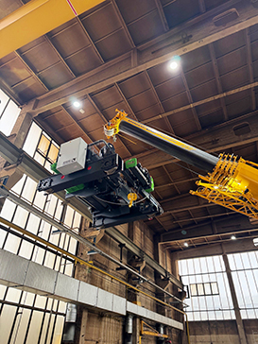

Image 2 Hoist installation
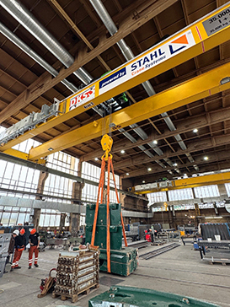

Image 3 Acceptance inspection by STAHL CraneSystems

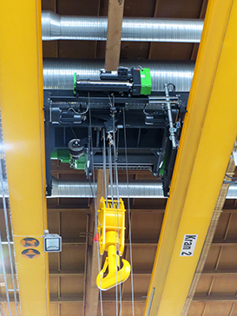

Image 4 Hoist in Crane
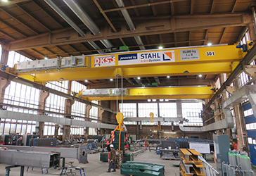

Image 5 Box girders and typical bridge elements
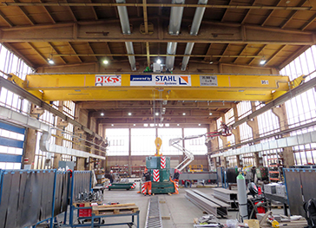
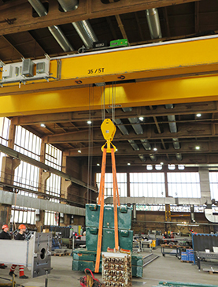

Image 6 + 7 Acceptance test with test weights

