1 February 2026

STAHL CraneSystems GmbH

Daimlerstraße 6

74653 Künzelsau

Contact person for questions regarding content:
Heike Metzger

Fon +49 7940 128-2388

Fax +49 7940 128-2300

heike.metzger@stahlcranes.com

www.stahlcranes.com

Crane modernisation in confined spaces

Customised CraneKit solution from STAHL CraneSystems with a lifting height of

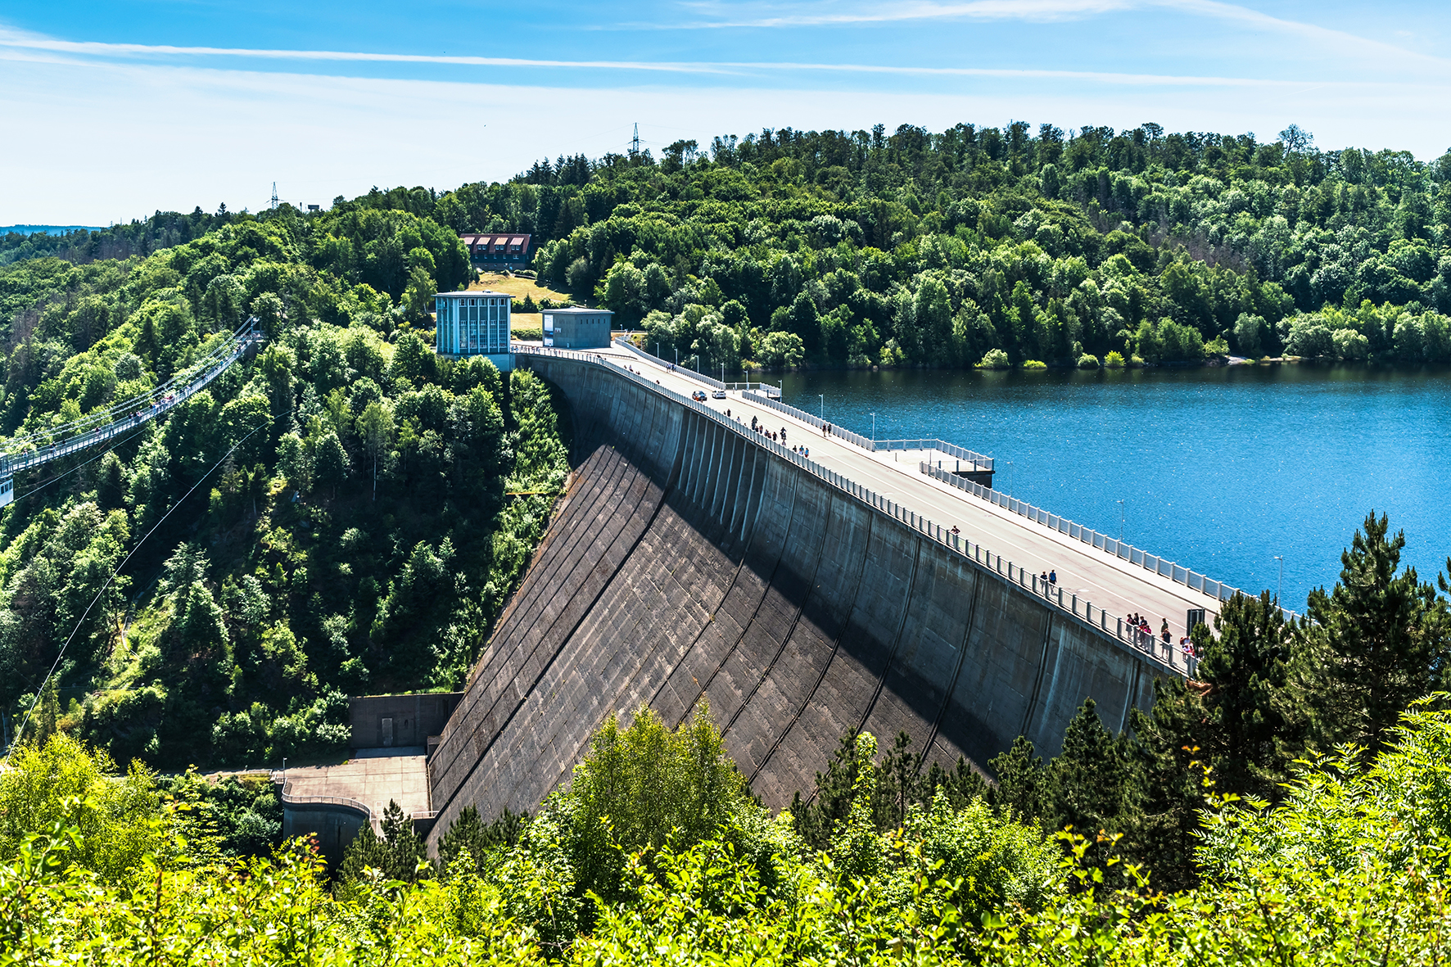
over 100 m for Germany's highest dam

The rope manufacturer Voigt Seil- und Hebetechnik in Bad Düben (Germany) is a certified service partner of STAHL CraneSystems and has completely replaced the crane system for opening the bulkhead at the bottom outlet in the Rappbode Dam. A sophisticated concept from the modular CraneKit system was used for this. The special design had to fit through a narrow hatch in the dam and be installed in the confined space inside the dam wall.

CraneKits from STAHL CraneSystems contain all the components required to build a crane system: rope hoists, winches, chain hoists, control and monitoring components, frequency converters for hoists, travel drives, crane head girders, accessories and many options, such as radio remote controls. A special solution has now been developed from this modular system, which went into operation in October 2025 at the Rappbode dam.

Largest dam in impressive natural surroundings

The Harz region is characterised by extensive forests, deep valleys, wild rivers and waterfalls – a large protected area where water management, nature conservation and tourism must be brought together. The Harz/Saxony-Anhalt Nature Park is an example of how this can be achieved. It is home to one of the two largest drinking water dams in Germany.

The Rappbode, like its tributary, the Hassel, is dammed by the 415-metre-long Rappbode Dam. The reservoir covers an area of almost four square kilometres. With a volume of around 110 million cubic metres of water, it is the largest reservoir in the Harz Mountains. At 106 m, the dam is the highest dam wall in Germany and, with around 47 million cubic metres of raw water per year, Germany's largest drinking water supply.

Gigantic dam with modern technology

The dam, which was built in 1959, consists of 30 wall sections with a maximum segment width of 16 metres, whereby the field joints provide a certain degree of flexibility and protect the very large rigid structure from cracking as far as possible. The valve and winch house, together with the operating equipment, are located at the south-eastern end of the dam. Due to its special structural features and uniqueness, this architectural giant was designated a "Historical Landmark of Civil Engineering in Germany" by the Federal Chamber of Engineers in 2022.

The dam systems have now become a complex water management system. Monitoring, maintaining and servicing the structures is a major challenge. The operator of a total of 36 dams is Talsperrenbetrieb Sachsen-Anhalt (TSB), based in Blankenburg. It is responsible for striking a balance between water supply and flood protection every day.

The entire Rappbode dam system, which consists of pre-dams and retention basins, contributes significantly to flood protection in the eastern Harz Mountains. In addition, an integrated power plant at the dam supplies electricity to surrounding villages. Without technical masterpieces, the optimal use of resources in harmony with nature would be inconceivable. Some of the technical equipment comes from STAHL CraneSystems, a company of the Columbus McKinnon Group.

Producing drinking water and energy in harmony with nature

The cranes installed in the confined space of the dam wall are used to open the bulkheads at the foot of the dam. This so-called bottom outlet is located on the water side of the dam wall. Basically, this closable opening is used to empty the dam to the lowest water level intended for normal operation. The bottom outlet is usually regulated by a gate valve. After passing through the outlet, the water flows into a catch basin to reduce the flow velocity.

Before the crane can open the bottom outlet, a submersible robot is lowered to the appropriate depth to hook the crane hook onto the eyelet of the bulkhead. As its name suggests, the bottom outlet is the deepest water extraction facility in a dam. This means that the lifting height of the crane and, due to the water load, its load capacity are crucial. There are two corresponding shafts in the Rappbode Dam, although only one has been modernised with a new crane from STAHL CraneSystems so far.

Modernisation by replacing a crane system that is over 65 years old

Emptying the dam is not a particularly quick process, sometimes taking weeks or even months. For this reason, the crane is only used occasionally throughout the year to open the bulkhead – but when it is used, it must be ensured that the crane is in full working order. The old crane, which was installed in 1960, was adequately dimensioned with a rope length of 96 m and a load capacity of 16 t, but due to decades of operation, it was increasingly in need of maintenance. For this reason, a comprehensive modernisation was planned for 2024.

The rope manufacturer Voigt Seil- und Hebetechnik in Bad Düben specialises in wire and fibre ropes as well as all solutions relating to rope and slinging technology. Due to the many possible applications of rope and lifting technology products, almost all sectors of the economy are among its customers, including TSB. Voigt is particularly committed to environmental protection and sustainability. The rope manufacturer has already provided service support to TSB in the past. For this reason, the modernisation project was also entrusted to this specialist in rope and lifting technology.

Reducing maintenance costs and increasing operational safety

A key factor in the project was to ensure the previous load capacity of 16 tonnes with an increased lifting height of 100 m, as the original 96 m was no longer sufficient. The crane, which dated back to the 1960s, had particular disadvantages in terms of the crane and trolley drives, which were still equipped with outdated and disruptive reel chains (chain drive). The new installation of the crane system also included the replacement of these manual drives with modern electric travel drives. The new solution impresses with its higher efficiency, reliability and travel speeds, as well as minimal maintenance, improved comfort and maximum user safety.

Due to structural challenges, the Voigt rope factory had to find a solution that would fit through a narrow hatch and into small spaces. The possible distance between the crane runway and the lower edge of the ceiling was very small, which is why a custom-made solution was necessary, which could best be designed with the CraneKit from STAHL CraneSystems. This allows such projects to be planned economically and executed quickly with manageable effort. Another advantage is its flexibility, which allows the respective solution to be adapted to specific requirements. STAHL CraneSystems produces all components of its CraneKits at its factory in Künzelsau (Germany).

Twin hoist with special features

A double-girder bridge crane with maintenance platform is now in use at the Rappbode Dam. The hoist is from the STAHL AS 7 wire rope hoist range. Users appreciate the modular system because of its tried-and-tested, low-maintenance components.

The twin hoist with a 2/2-1 hook configuration offers a maximum lifting height of 102 m for loads of up to 16 t. The counter-rotating rope guide prevents hook drift, enabling heavy loads to be lowered with great precision. The hoist travels a distance of 12 m with a span of 6.3 m in order to open the bulkhead for the bottom outlet and perform further lifting work to. It is mounted on an upper girder trolley and requires only a low ceiling height, making it ideal for use in the dam wall of the Rappbode dam system.

As this is a twin hoist, only one of the hoists has overload protection. The load is measured at the torque support of the gearbox by means of a pressure sensor attached to the supporting structure. This allows load measurements to be taken even in the lower partial load range with a high accuracy of ± 6% of the nominal load. The SMC22 Multicontroller is used as the control unit. It is mounted directly on the hoist and records the most important operating data in real time. With its continuous load control, it can immediately shut down the hoist in the event of overload.

The travel and hoist mechanisms and the rope drums with customised lengths are all custom-made. In addition, the stationary YALE-VSIII spur gear block is attached to both sides of the trolley for maintenance purposes. The two maintenance chain hoists have a load capacity of 500 kg and a lifting height of 4 m in order to optimally meet the requirements of typical maintenance and auxiliary work in the dam wall. The special solution is complemented by a hook block designed for underwater operation.

Difficult on-site installation

Each CraneKit is pre-assembled upon delivery and contains all necessary documentation and instructions. The crane system is assembled on site according to the user-friendly plug-and-play principle. However, there were a few hurdles to overcome when implementing the solution at the Rappbode Dam: due to the limited space available, dismantling the old crane and installing the new one inside the dam wall was particularly difficult.

The crane components had to be lifted from the road through a narrow 2 m x 4 m hatch in the dam wall using a mobile crane. This is a real challenge with components that are sometimes over 6 m long due to their span. Space was also tight below the hatch. The possible distance between the crane runway and the lower edge of the ceiling was very small. This meant that the project required a skilful approach to the installation of the special hoist design.

Despite the difficult circumstances, the project was completed in a short time. Planning, ordering and production began in July 2024, implementation on site in September 2025, and commissioning took place in October 2025. Further projects between STAHL CraneSystems and Voigt Seilerei are already in the planning stage.

Author: Heike Metzger, Senior Specialist, Sales Enablement, STAHL CraneSystems GmbH, Künzelsau (Germany)

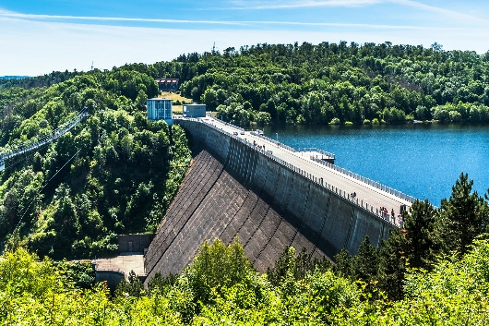
Images and captions

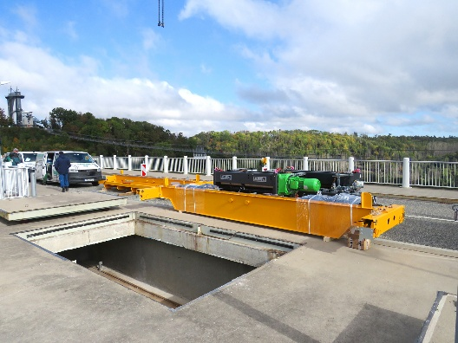
The Rappbode Dam is a "historic landmark of civil engineering in Germany".

With an opening of only 2 m x 4 m, the hatch and the installation space are extremely narrow.
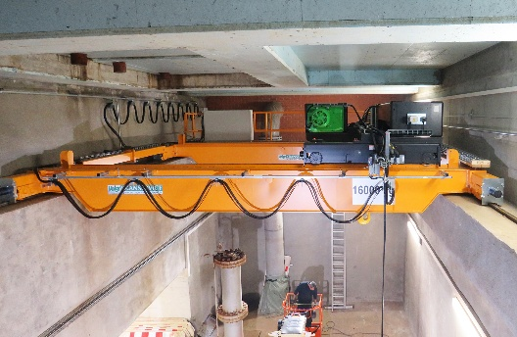

Double-girder bridge crane with twin hoists and continuous load monitoring
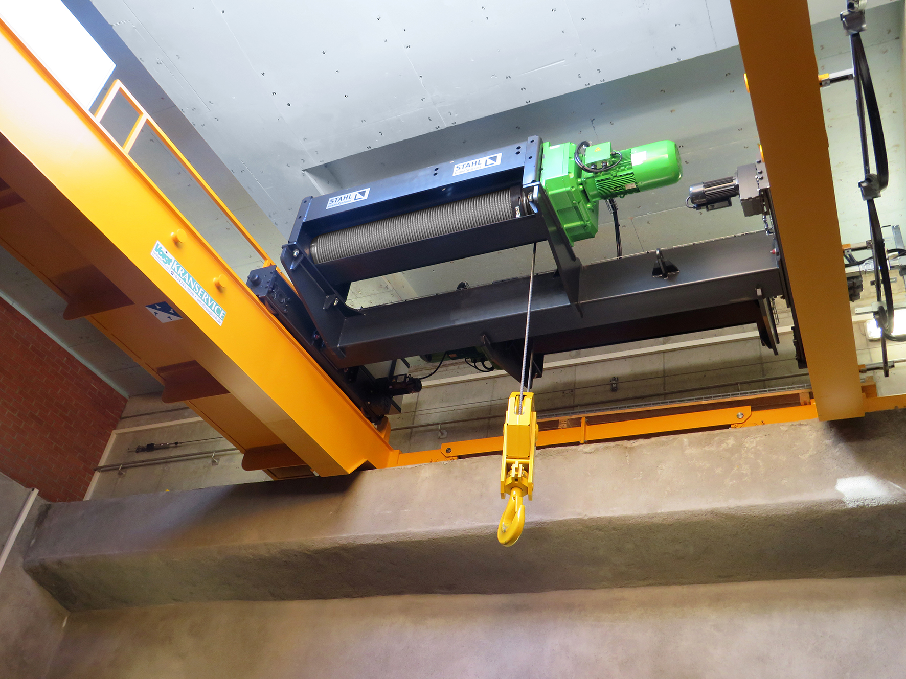

Wire rope hoist from STAHL CraneSystems for a maximum lifting height of 102 m

and load capacities up to 16 t

